Mathematics Department Autumn – UNIVERSITY NAME PGCE
Included in this pack of information is a specific timetable until half term and a general timetable thereafter and also details of how to access the departmental schemes of work and handbook that details all of the departmental policies and procedures.
During this induction period, you will be provided with details of the topics which you are to teach (or the point in the scheme of work from which you will be expected to continue), and you are advised to obtain set lists and seating plans during the observation of these classes that you will undertake as part of your induction.
A note on observations
As you will be observing some of the classes which you will be teaching it is beneficial that, in addition to gathering information, you use the opportunity to focus on the different strategies that the teachers use for managing behaviour from start and end of lesson routines to how resources, books etc are distributed.
Departmental policies/procedures
You will have been given access to the schools intranet site and you will need to familiarise yourself with the information in relation to the maths department.
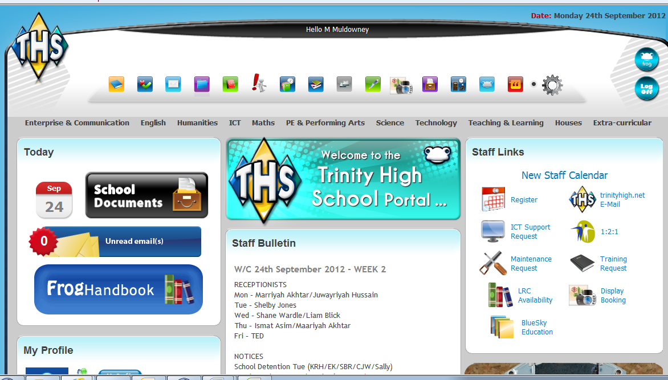
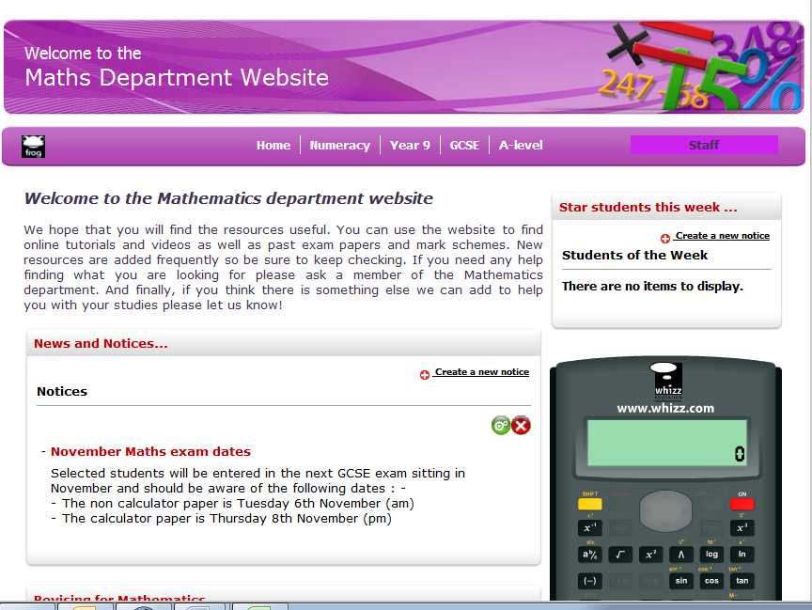
Note that the resources section is still a work in progress

Timetable overview:
After half term, your timetable will be as follows:
Colour | Teacher | Comment
9X4 MRM (13) | MRM | x 6 per fortnight solo teaching
9Y4 | CS/MRM | x 6 per fortnight collaborative (and solo) teaching with other student partner
11Y3 MRM (13) | MRM | x 4 per fortnight collaborative teaching with student teacher
11Y3 | MRM | MRM teaches (students in professional mentor meeting usually FRI P1)
Year 12 applied | MRM/NK | Year 12 Applied (decision NK (15) or mechanics MRM (13))
 | Various | Observations/ Support
GENERAL TIMETABLE (wk1)
 | MON | TUES | WED | THUR | FRI
1 | 11X2 CGI (16) | - | 9X4 MRM (13) | 9Y4 MRM (13) | 11Y3 MRM - PROF MENTOR MEETING
2 | 10X4 NK (15) | 10X4 NK (15) | - | 11Y3 MRM (13) | -
3 | 9X4 MRM (13) | 10Y3 CS (14) | 10Y3 CS (14) | 11X2 CGI (16) | 9Y4 MRM (13)
4 | 10Y3 CS (14) | 9Y4 CS (14) | 10X4 NK (15) | Year 12 Applied (MRM/ NK) | -
5 | 11Y3 MRM (13) | - | - | 9X4 MRM (13) | 11X2 CGI (16)
GENERAL TIMETABLE (wk2)
1 | 11X2 CGI (16) | - | 9X4 MRM (13) | 9Y4 MRM (13) | 11Y3 MRM - PROF MENTOR MEETING
2 | 10X4 NK (15) | 10X4 NK (15) | - | 11Y3 MRM (13) | -
3 | 9X4 MRM (13) | 10Y3 CS (14) | 10Y3 CS (14) | 11X2 CGI (16) | 9Y4 MRM (13)
4 | 10Y3 CS (14) | 9Y4 CS (14) | 10X4 NK (15) | Year 12 Applied (MRM/ NK) | MATHS FACULTY MEETING
5 | 11Y3 MRM (13) | - | - | 9X4 MRM (13) | 11X2 CGI (16)

Induction timetable 1
WC 1ST OCT 2012 (wk 1)
 | MON | TUES | WED | THUR | FRI
1 |  |  |  | 9Y4 MRM (13) | 11Y3 MRM - PROF MENTOR MEETING
2 |  |  |  | MENTOR MEETING WITH DW | Meet with MRM
3 |  |  |  | 11X2 CGI (16) | 9Y4 MRM (13)
4 |  |  |  | Year 12 Applied (MRM/ NK) | -
5 |  |  |  | 9X4 MRM (13) | 11X2 CGI (16)
6
Comments |  |  |  |  | Read behaviour policy

Induction timetable 2
WC 8TH OCT 2012 (wk 2)
 | MON | TUES | WED | THUR | FRI
1 | 11X2 CGI (16) | Sci 9X3 (Room 22) | 9X4 MRM (13) | 9Y4 MRM (13) | 11Y3 MRM - PROF MENTOR MEETING
2 | 10X4 NK (15) | Art 9X6 (Room 67) | - | 11Y3 MRM (13) | -
3 | 9X4 MRM (13) | RE - E Lynch (Room 29 a) | 10Y3 CS (14) | 11X2 CGI (16) | 9Y4 MRM (13)
4 | 10Y3 CS (14) | 9Y4 CS (14) | 10X4 NK (15) | Year 12 Applied (MRM/ NK) | MATHS FACULTY MEETING
5 | 11Y3 MRM (13) | - | - | 9X4 MRM (13) | 11X2 CGI (16)
6 |  | MEET WITH SENCO after school (W Andrews Room 6)
Comments | Focus on behaviour managment | Shadow a group of students for the morning | Focus on the use of questioning to scaffold learning | Focus on inclusion issues | Focus on use of teachers language

Induction timetable 3
W/C 15TH OCT 2012 (wk1)
 | MON | TUES | WED | THUR | FRI
1 | 11X2 CGI (16) | - | 9X4 MRM (13) | 9Y4 MRM (13) | 11Y3 MRM - PROF MENTOR MEETING
2 | 10X4 NK (15) | 10X4 NK (15) | - | 11Y3 MRM (13) | -
3 | 9X4 MRM (13) | 10Y3 CS (14) | 10Y3 CS (14) | 11X2 CGI (16) | 9Y4 MRM (13)
4 | 10Y3 CS (14) | 9Y4 CS (14) | 10X4 NK (15) | Year 12 Applied (MRM/ NK) | -
5 | 11Y3 MRM (13) | - | - | 9X4 MRM (13) | 11X2 CGI (16)
6
Comments |  | Focus on pupil motivation |  | Focus on TA support where applicable

Additional information
- Photocopying can be done in the staff work room – you will need to take paper (from either room 11 or the stock cupboard) and the code for the machines is XXXX.

Contact Details
Please feel free to email me on SCHOOL EMAIL or PERSONAL EMAIL or should you need to contact me via phone or text my mobile number is MOBILE NUMBER

