Download your results plus data and save somewhere obvious – when you open it, it should look like the below ...
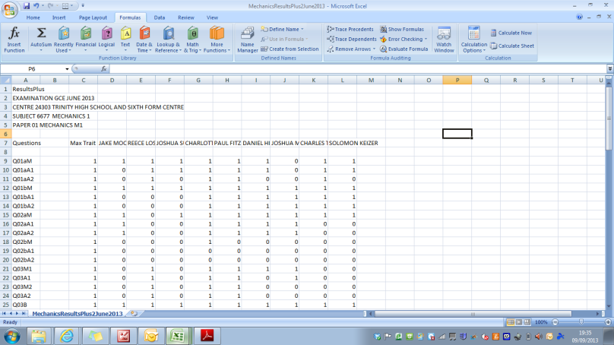
STEP 1 ... You need to delete the blank row between your student names and the results
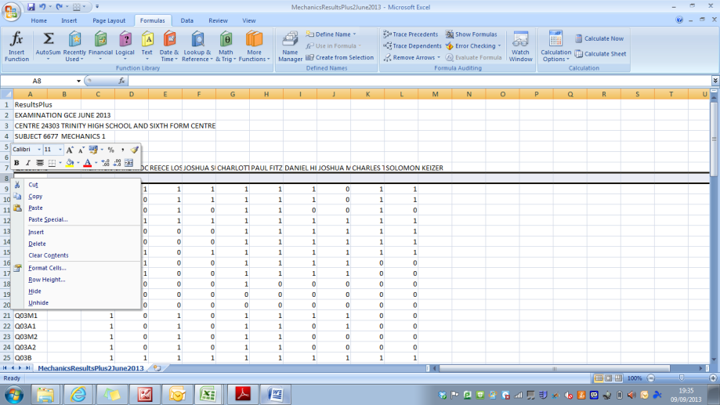
STEP 2 ... Highlight the data from the first students name on the ResultsPlus data down to the bottom right hand side of the last students name ... and copy and paste into Cell B1 of the Template.
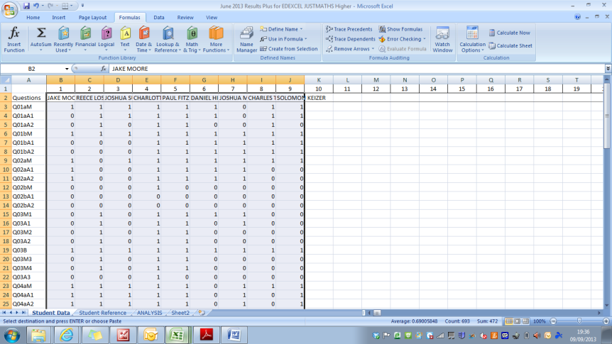
TO USE THE TEMPLATE – Enter the “students reference number” (from the sheet with the same name) into the ANALYSIS sheet (at the top – there is a box to enter it) one at a time and print.

