The attached template has been set up for you to use, with the question –by-question information in relation to the JUNE 2014 EDEXCEL LINEAR 1MA0. This document includes two “How to” sections
- How to use the template
- How to import your own schools’ data into the workbook.
How to use the ResultsPlus Template
This workbook works by using “lookup” tables from 2 sheets which are downloaded from Edexcel and copied into the workbook. To use the analysis you need the student reference number from the student reference sheet (one of the tabs at the bottom) which is entered into CELL D1. All of the data for that specific student is pulled onto the main sheet as shown below. This can then be printed on one page.
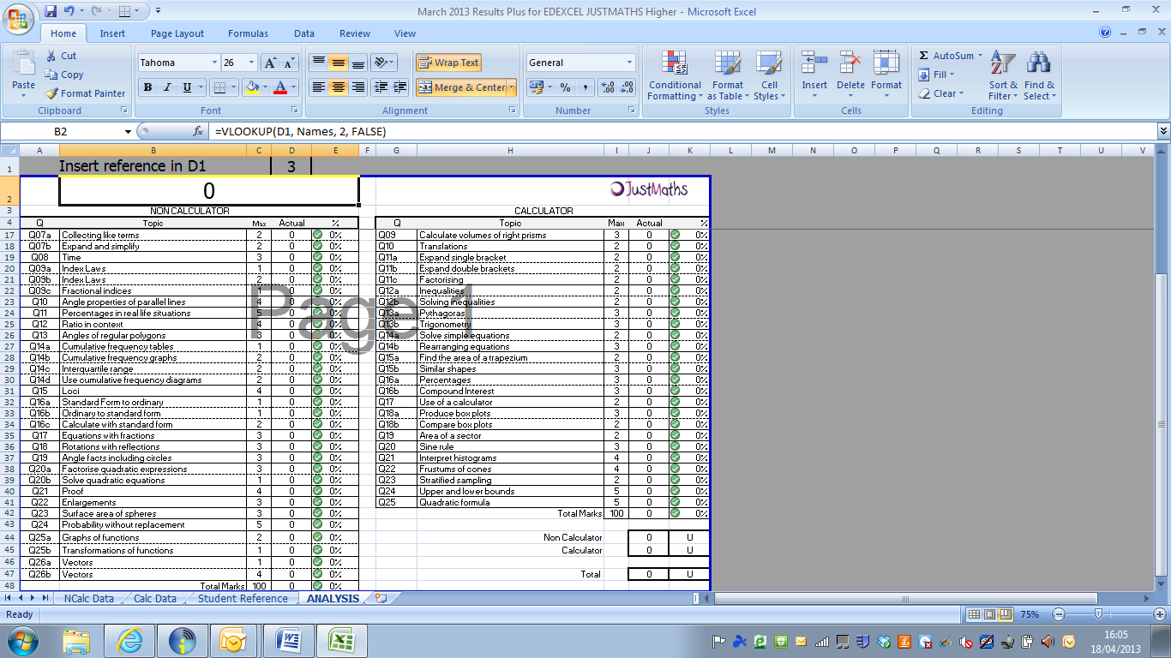
Importing your own data
Download the 2 higher files from Edexcel and save somewhere obvious on your computer.
STEP 1 - Open the ResultsPlus template and the Non Calculator (H) workbook which should look like this when opened.
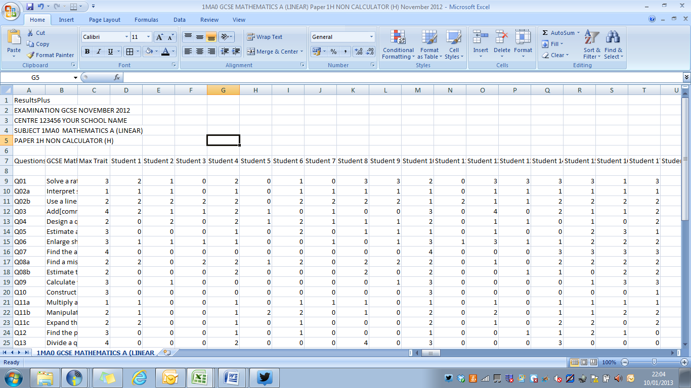
STEP 1 - delete the row underneath the student names, so that the sheet now looks like this:
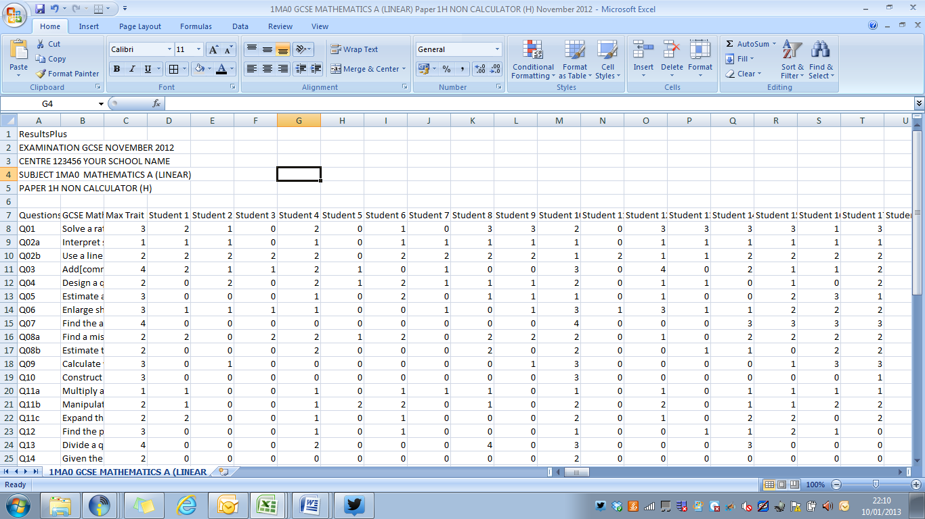
STEP 2 - You now need to copy and paste the data (NOT ALL OF IT – AND IT IS IMPORTANT YOU COPY THE CORRECT CELLS) – Highlight the cells from (and including the first students’ name) and drag your cursor to the end of the data
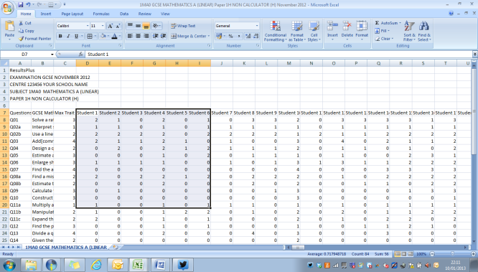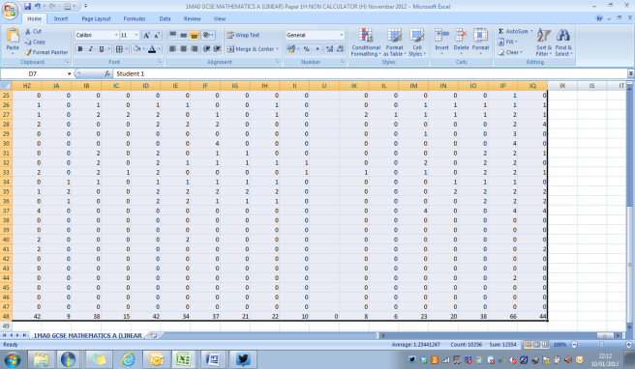
STEP 3 - Once you have highlighted this data (and clicked copy) – go to the ResultsPlus template and click on the “Non Calc” tab, put your cursor in cell B2 and click “paste”.
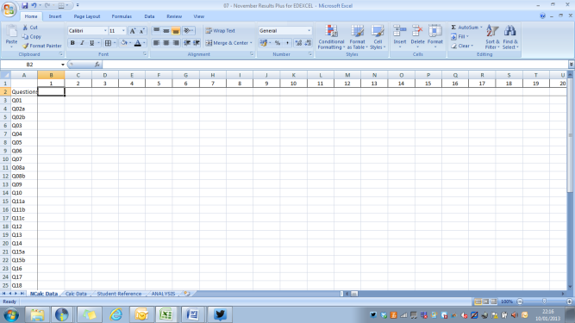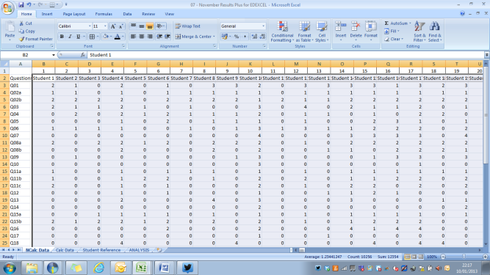
STEP 4 - Open the 2H file and repeat the above step of deleting a row and copying and pasting – this time you will need to paste into the Calc Data tab at the bottom of the template.
STEP 5 - One final check that this has worked. On the student reference file under the (Non Calc) student name and (Calc) student name MUST be the same. I have never known them to not be the same, but if they don’t match, unfortunately importing the data is a bit trickier. I am happy to do this for you if you send me your schools’ files. Obviously the data will be destroyed etc after creating your specific excel workbook.
MATCHING NAMES ON STUDENT REF SHEET 1
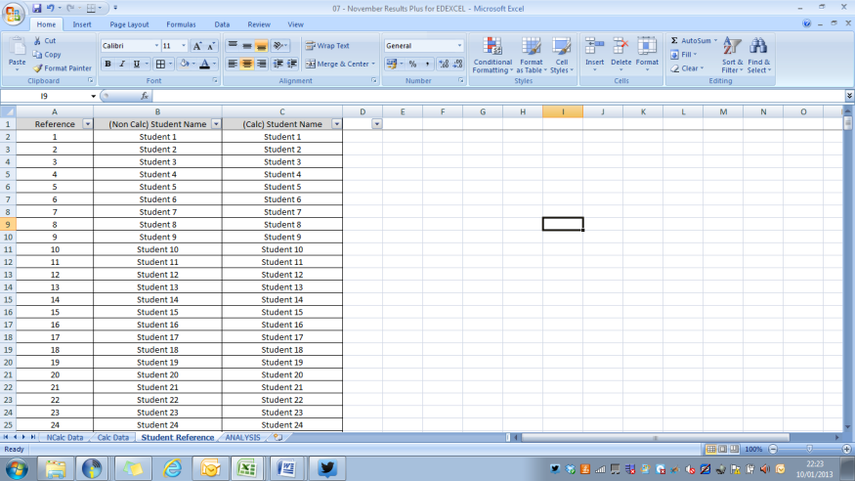
THE WORKBOOK IS NOW READY TO USE

