Mαthεmαtics
INSERT LOGO HERE
∂εpαrtmεnt
Mathematics is taught in a suite of five classrooms, and each classroom is fitted with an interactive whiteboard to improve the learning experience. Within the Mathematics area there is a resource room, suitable for small group teaching. The faculty subscribes to a number of electronic resources to enhance the learning of the students - Resources available include interactive tutorials which specifically support the courses that our students follow, websites that help students to enhance their skills, and to support students in their learning and investigatory skills.

KEY STAGE 3
Students study the Mathematics National Curriculum and through this we aim to develop in our students:
- A positive attitude towards Mathematics as well as competence and confidence in mathematical knowledge, concepts and skills
- An ability to solve problems, to reason, to think logically and to work systematically and logically
- The skills to use their own initiative and an ability to work both independently and in co-operation with others
- An ability to communicate through mathematics, and to use and apply mathematics across the curriculum and in real life

KEY STAGE 4
Students are prepared to sit their GCSE examination using the Edexcel Linear course (1MA0) which contains two examinations (calculator and non-calculator) with grades determined by performance across both papers. Students are fully supported throughout the course with excellent resources, targeted teaching and many opportunities to attend extra support sessions. One to one tuition is also provided for selected students.
Our current year 11 will also be studying either Further Mathematics or GCSE Statistics.
REVISION
www.justmaths.co.uk/online
Username = XXXXXXX
Password = XXXXXXX
We recommend students are purchase (and more importantly use them!) the Edexcel Revision Guide and Workbook available at £2.50 each (cheaper than the High Street) and in addition for year 11 students studying:
- Further Mathematics please see XXXXX
- Statistics. We recommend the CGP revision guide and workbook – we will provide more information in due course
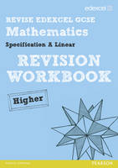
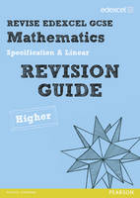
Student Name: ________________________________
GCSE Revision Guide £2.50 _____
GCSE Workbook £2.50 _____
