Superhero
Problem Solvers
Maths Problem?

Follow these steps to help.

What is the question asking?

What information have you been given?

What maths skills/formulas will you need to use?

What strategy could you use?

How can you review your workings and answer?

Superhero solving strategies to help you …

Capt America = x unknown
Spiderman = diagram
Wonderwoman = flow diagram
Batman = draw a table
Supergirl = look for pattern
Hulk = simpler numbers

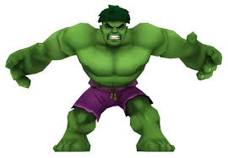

Using $x$ as the unkown

Using a diagram

Look for a pattern

Draw a table

Use simpler numbers

Use a flow diagram

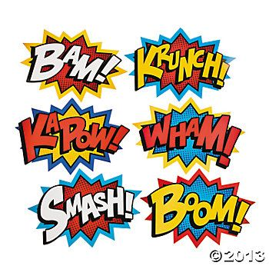

Problem Solving Plan
What is the question asking?
What information have you been given?
What mathematics skills/formulas will you need to use?
What problem solving strategies could you use?
How can you review your workings and answer?

Problem Solving Plan
What is the question asking?
What information have you been given?
What mathematics skills/formulas will you need to use?
What problem solving strategies could you use?
How can you review your workings and answer?

