Learning Objective: | To be able to reflect a shape and to be able to | Date:
 | describe reflections.

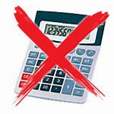
Do NOW Activity:

- Calculate 1.12 + 0.2
- Convert 23 cm to mm
6 cm
- Calculate $\frac{2}{3}$ of 24
- What is the perimeter?
3 cm
- Simplify: $x^{2} × x^{4}$
- Estimate 321 x 12

NOTES: (If needed, make any notes to help you answer similar questions next week)

PRIOR KNOWLEDGE CHECK:
You will be aware that there are FOUR transformations. Reflections are just one of them. You will be able to recognise straight line graphs of y = x, y = -x, y = “a” and x = “a” If you need help with this (we will check during the lesson) please ask for help.
THE MAIN EVENT
Worked example 1.  Reflect the shape below in the mirror line.  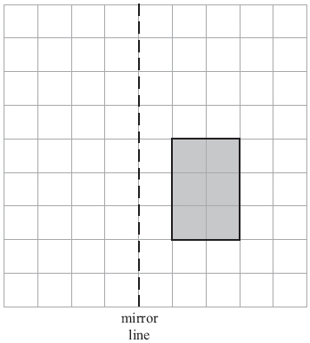 | Now try this:  Reflect the shape below in the mirror line.  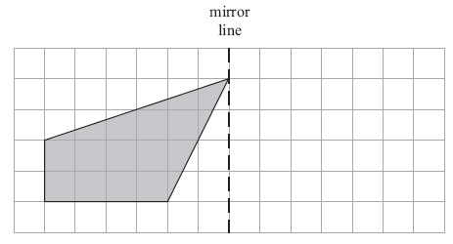
Notes:

Worked example 2.  1. Reflect shape A in the line x = 1, label the new shape B  2. Reflect shape B in the line y = -2, label the new shape C  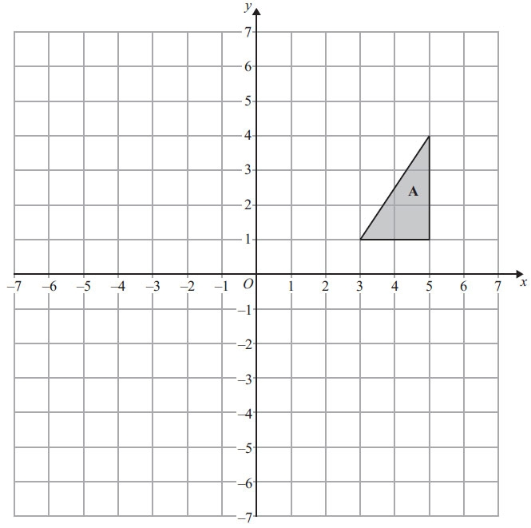 | Now try this:  1. Reflect shape P in the line x = -2, label the new shape Q  2. Reflect shape P in the line y = 1, label the new shape R  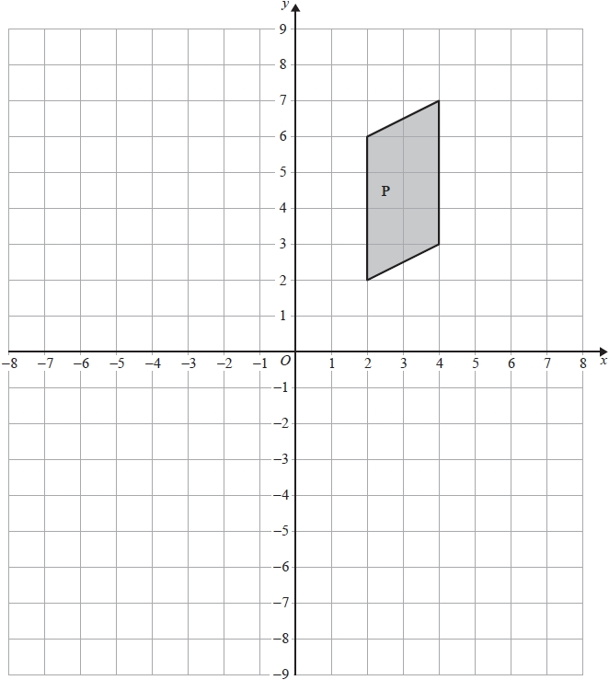
Notes:

Worked example 3:  Reflect shape A in the line y = x, label the new shape B  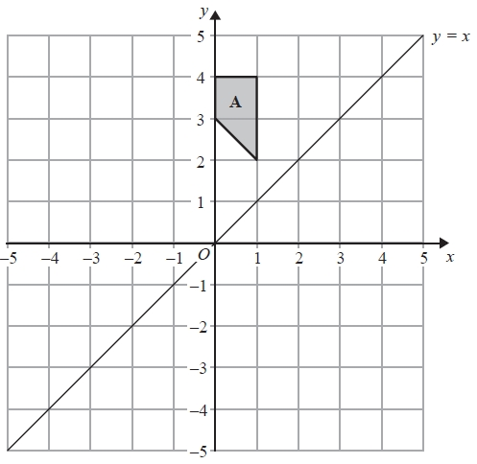 | Now try this:  Reflect shape P in the line y = x, label the new shape Q  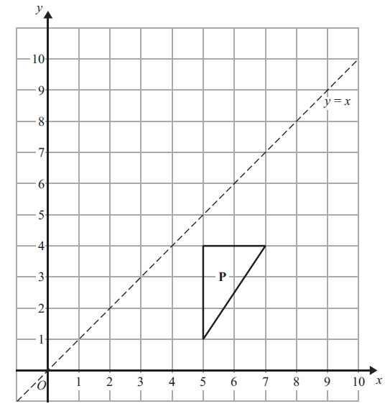
Notes:

Worked Example 4.  Describe fully the single transformation that maps shape A onto shape B.  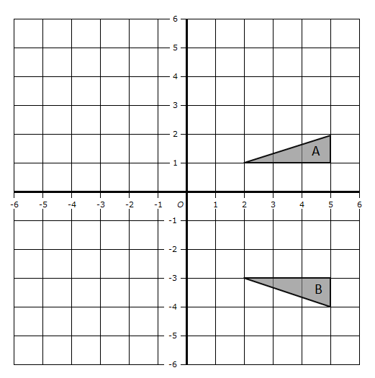 | Now try this:  Describe fully the single transformation that maps shape B onto shape A.
Notes:

R.A.G. Questions  Reflect shape A in the line y = -x, label the new shape B  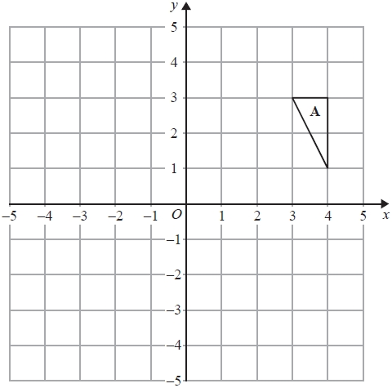 | Describe fully the single transformation that maps shape C onto shape B.  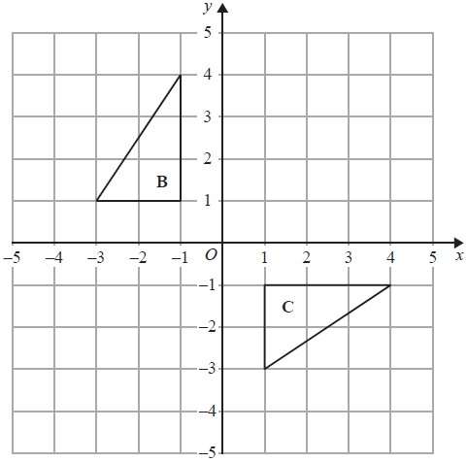

When considering your effort think about whether you have followed all instructions, made notes, marked your work and completed all the work that you were asked to do. | EFFORT  RED AMBER GREEN | UNDERSTANDING  1 2 3

NOTES

